Established – 1961 Subject: ___________
SEVA SADAN’S


OF
ARTS, SCIENCE & COMMERCE
ULHASNAGAR – 421 003

CERTIFICATE

This is to certify that Mr./Ms. ________________________________ of S.Y. Computer Science (SYCS) Roll No.
_____________________________ has satisfactorily completed
The Internet Of Thing Mini Project entitled_________________
_________________________________________________________
__
during the academic year 2025 – 2026, as a part of the practical requirement. The project work is found to be satisfactory and is approved for submission.

PROF. INCHARGE HEAD OF DEPT

________________ _________________

INDEX

Sr. No. | Chapters | Page No.
1 | Introduction
2 | Requirement Specification
3 | System Design
4 | Implementation
5 | System Testing and Result
6 | Future Scope and Conclusion
7 | References
8 | Glossary



Introduction :
Water is very important in our daily life. We use water for drinking, cooking, washing, cleaning, farming, and many other purposes. In many houses and buildings, water is stored in overhead tanks. People usually turn on the motor manually to fill the tank. Sometimes they forget to turn it off, which causes water overflow and wastage.
To solve this problem, we designed an Automatic Water Level Controller using ESP8266. This system automatically checks the water level in the tank and controls the water pump. When the tank is empty, the motor turns ON automatically. When the tank becomes full, the motor turns OFF automatically.
This system saves water, electricity, and human effort.

- Motivation :
The motivation behind developing the IoT Based Heart Rate Monitoring System is the growing need for simple and affordable health monitoring solutions. Monitoring heart rate regularly can help in understanding a person’s health condition and detecting abnormalities at an early stage.
This project provides an educational and practical way for students to learn about IoT concepts, sensor interfacing, and wireless communication. It also demonstrates real-world applications of IoT in healthcare, remote patient monitoring, and fitness tracking systems.

- Problem Definition :
In many homes and industries:
- Water tanks overflow because people forget to turn off the motor.

- Water gets wasted.
- Electricity is wasted due to unnecessary motor running.
- Continuous overflow can damage walls and buildings.
- Manual checking of tank level is difficult and time-consuming.
There is a need for an automatic system that:
- Monitors the water level continuously.
- Controls the motor automatically.
- Prevents overflow.
- Works without human supervision.
The Automatic Water Level Controller solves these problems efficiently.

How it Works :
The system mainly uses:
- ESP8266 (NodeMCU)
- Water Level Sensor
- Relay Module
- Water Pump
Working Process:
- The water level sensor is placed inside the tank.
- The sensor detects the water level and sends signals to the ESP8266.
- The ESP8266 reads the sensor value.
- If the water level is LOW:
  - ESP8266 sends a signal to the relay.
  - Relay turns ON the water pump.
- If the water level is FULL:
  - ESP8266 turns OFF the relay.
  - Motor stops automatically.
The ESP8266 works as the brain of the system and makes decisions based on sensor input.
Since ESP8266 has WiFi capability, the system can also be upgraded to IoT-based monitoring in the future.

Key Features :
- Automatic motor ON/OFF control
- Prevents water overflow
- Saves water and electricity
- Low cost and easy to install
- Uses WiFi-enabled ESP8266
- Reliable and accurate monitoring
- Low power consumption
- Can be upgraded to IoT system

- Scope of the Project :
The scope of this project is wide and useful in many areas:
- Houses and apartments
- Schools and colleges
- Hospitals
- Industries
- Agriculture water tanks
- Commercial buildings
Future improvements can include:
- Mobile app monitoring
- SMS or email alerts
- LCD display to show water level
- Cloud data storage
- Smart home integration
This project can be expanded into a complete smart water management system.
Objective :
The main objectives of this project are:
- To design an automatic water level monitoring system.
- To control water pump automatically using ESP8266.
- To prevent water overflow.
- To reduce manual effort.
- To save water and electricity.
- To build a low-cost and efficient system.
- To create a system that can be upgraded to IoT.

Key goals include :
The key goals of this project are:
- Develop a reliable automatic control system.
- Ensure accurate detection of water levels.
- Achieve efficient motor control.
- Minimize water wastage.
- Reduce electricity consumption.
- Provide a smart and modern solution.
Make the system simple and user-friendly





1.1 ESP8266 (NodeMCU)
- It is the main controller of the system.
- It reads the signal from the water level sensor.
- It processes the data and makes decisions.
- It has built-in WiFi capability.
- Operating voltage: 3.3V
- It is programmed using Arduino IDE.
1.2 Water Level Sensor
- Used to detect the level of water.
- It senses the amount of water present.
- Sends signal to ESP8266.
- Can provide analog or digital output.
- Placed inside the tank for measurement.
1.3 Breadboard
- Used to connect components without soldering.
- Helps in easy testing and modification.
- Provides temporary electrical connections.
- Makes the circuit neat and organized.
1.4 Jumper Wires
- Used to connect ESP8266 and water sensor.
- Ensures proper signal and power connection.

2. Software Requirements
2.1 Arduino IDE
- Used to write and upload program.
- Supports ESP8266 board.
- Simple and easy interface.
2.2 ESP8266 Board Package
- Installed in Arduino IDE.
- Required to program ESP8266.
2.3 Embedded C / Arduino Programming Language
- Used to write the program logic.
- Reads sensor value.
- Controls system operation.



Block Diagram :

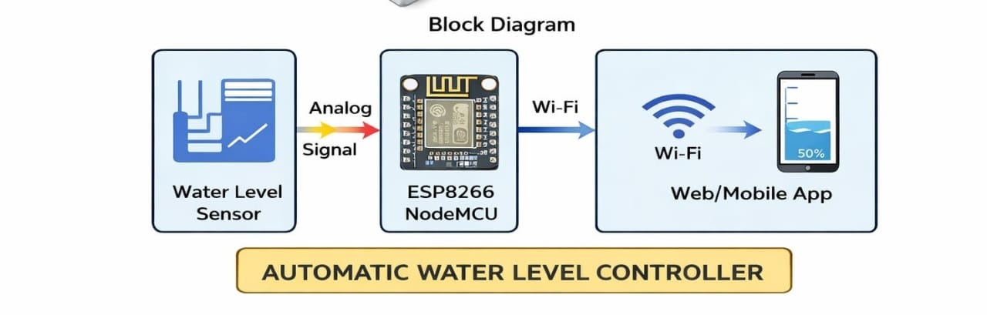
Block Diagram Description

This block diagram represents the working of an Automatic Water Level Controller using ESP8266 NodeMCU and a Water Level Sensor.

🎯 Purpose of Block Diagram
A Block Diagram is used to:
Show the overall working of the system
Explain how components are connected
Represent data flow in simple form
Make project explanation easy

It shows the system in simple blocks instead of technical wiring details.
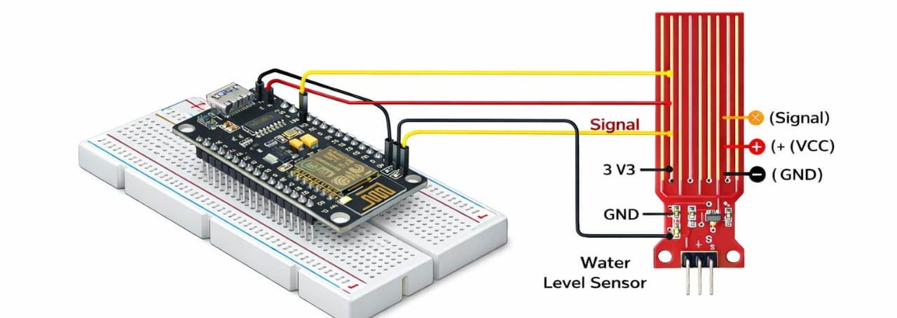
Description : A Water Level Monitoring System using ESP8266 is an IoT-based project that detects and monitors the level of water in a tank or container. It uses a water level sensor to measure water presence and an ESP8266 WiFi module to process data and send it to the internet or a mobile application.
This system helps prevent:
- Water overflow
- Dry running of motors
- Water wastage
- Tank empty situations
Working Principle:
- The sensor has parallel exposed copper traces.
- When water touches the traces, it completes the circuit.
- The output voltage changes according to the water level.
- It provides analog and digital output.
Features:
- Operating Voltage: 3.3V – 5V
- Low power consumption
- Provides analog output (A0)
- Easy interface with microcontrollers
- Corrosion-resistant (when properly maintained)

Use Case Diagram :
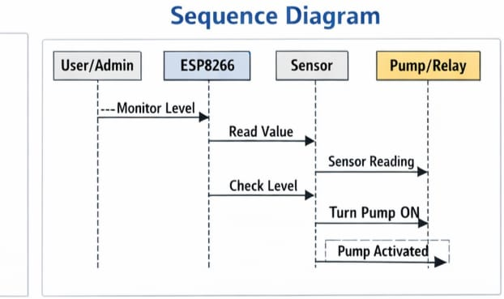
Description :
This diagram represents the working process of an Automatic Water Level Controller using ESP8266 NodeMCU, a water level sensor, and a pump/relay.

🔎 Purpose of Sequence Diagram

A sequence diagram shows:
The order of operations
How different components communicate
Step-by-step flow of the system
Time sequence of messages

It helps us understand how the system works internally from start to finish.

Activity Diagram :
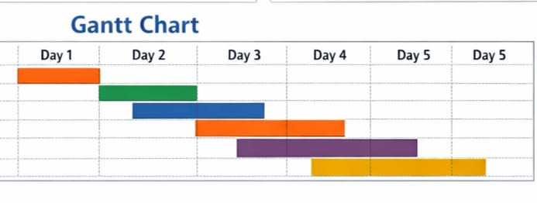Description :
The horizontal axis is divided into time periods labeled:
Day 1
Day 2
Day 3
Day 4
Day 5 (Day 5 appears twice, likely a formatting mistake)
There are multiple colored horizontal bars representing different tasks:
An orange bar starting on Day 1.

A green bar starting around Day 2.
A blue bar spanning across Day 2 and Day 3.
Another orange bar starting on Day 3 and extending toward Day 4.
A purple bar covering Day 3 to Day 5.
A yellow bar starting around Day 4 and continuing to Day 5.

Class diagram
Class Diagram :
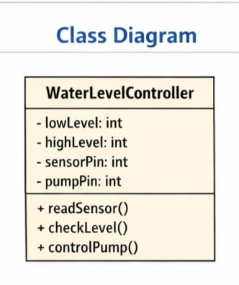
Class Diagram : Description
This diagram represents the structure of a class named WaterLevelController used in an Automatic Water Level Controller project with ESP8266 NodeMCU.

🎯 Purpose of Class Diagram
A Class Diagram shows:
Structure of the system
Variables (data members)
Functions (methods)
Blueprint of program design

It helps in understanding how the software is organized before coding.
Class: WaterLevelController
🔹 Data Members (Variables)
These are private (– sign means private):
lowLevel : int
→ Stores minimum water level value
highLevel : int
→ Stores maximum water level value
sensorPin : int
→ Stores pin number connected to water senso



Step-by-Step Assembly:

Step 1 :
Firstly, identify these components.
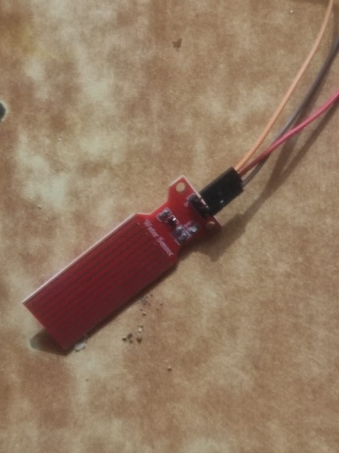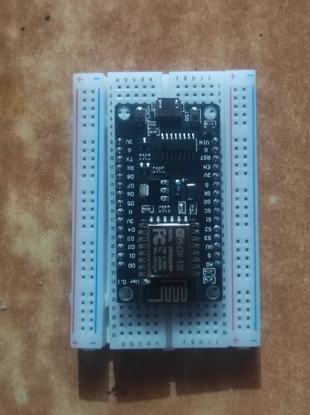

Step 2 :
Place all components on Breadboard :
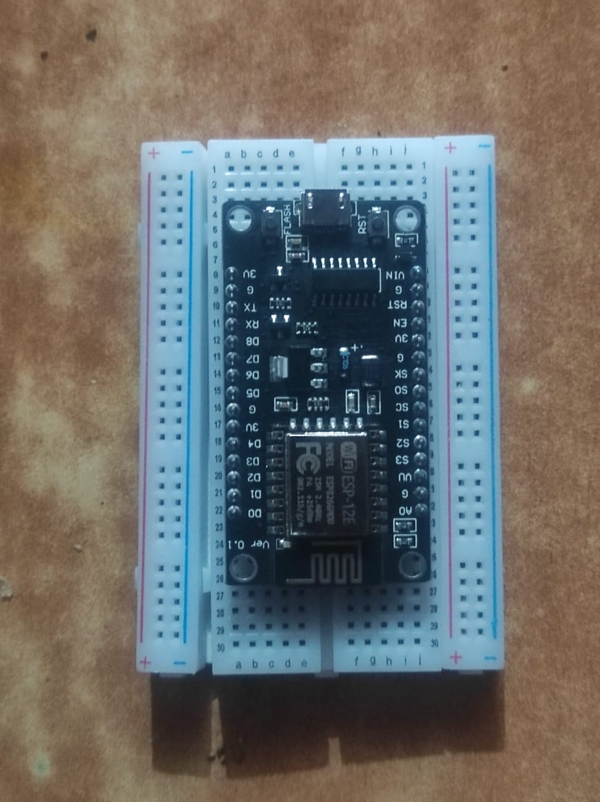
Step 3 :
Connect water level sensor jumper wires on following pins.
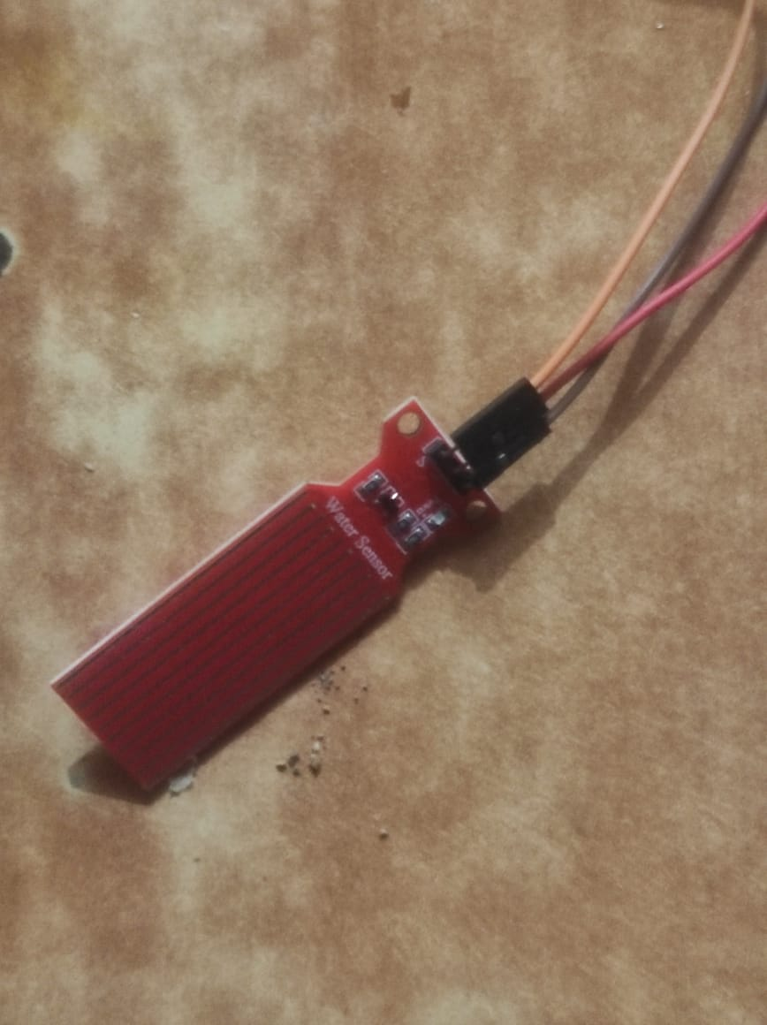

Step 4 :
So, let’s create the program for this project. This program includes all three functions. We can run these separately. It is as follows.

int waterSensor = A0;

int lowLevel = 400; // He value change karu shakto
int highLevel = 700; // He value change karu shakto

void setup() {
Serial.begin(9600);
Serial.println("Water Level System Started");
}

void loop() {

int sensorValue = analogRead(waterSensor);

Serial.print("Sensor Value: ");
Serial.print(sensorValue);
Serial.print(" | Water Level: ");

if(sensorValue < lowLevel) {
Serial.println("LOW");
}
else if(sensorValue >= lowLevel && sensorValue < highLevel) {
Serial.println("MEDIUM");
}
else {
Serial.println("HIGH");
}

delay(1000);
}



Step 6 :

Connect Datacable from Esp8266 to laptop for code uploading.
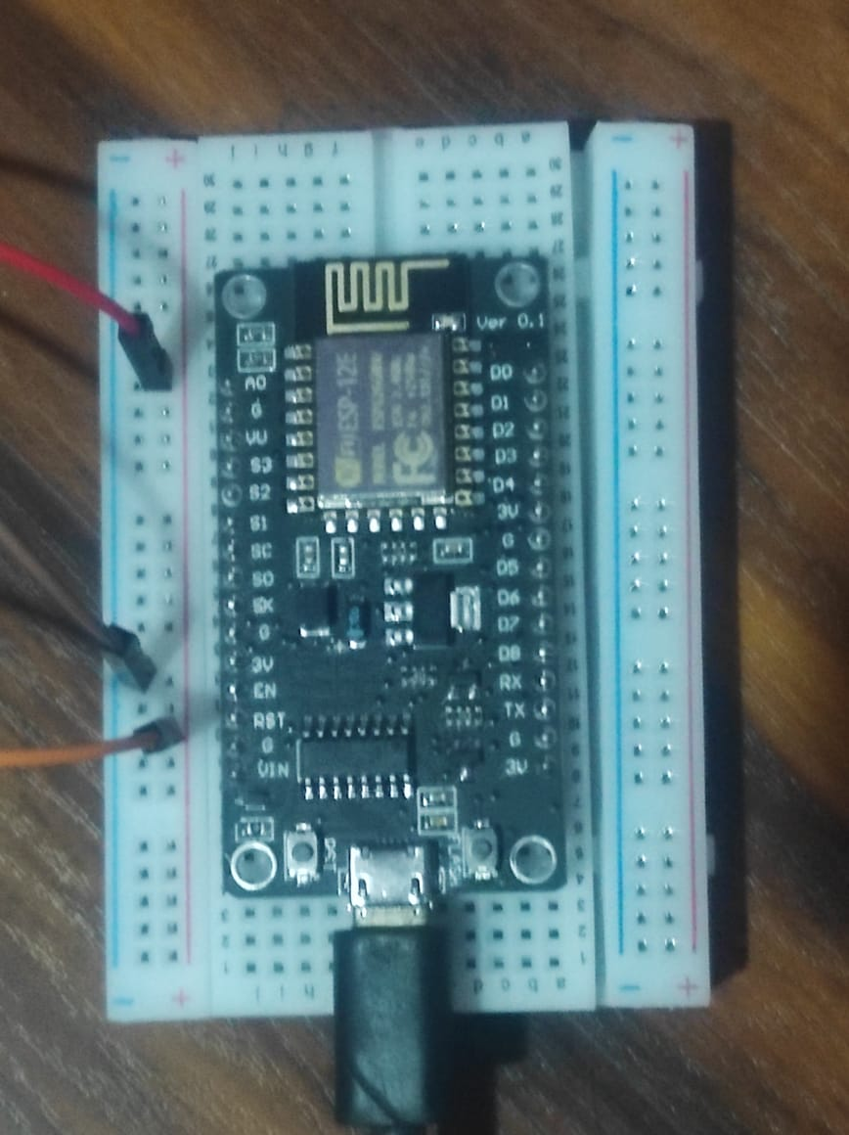
Step 7:Open Arduino IDE,and select Board and Ports,after that type the code on Arduino IDE
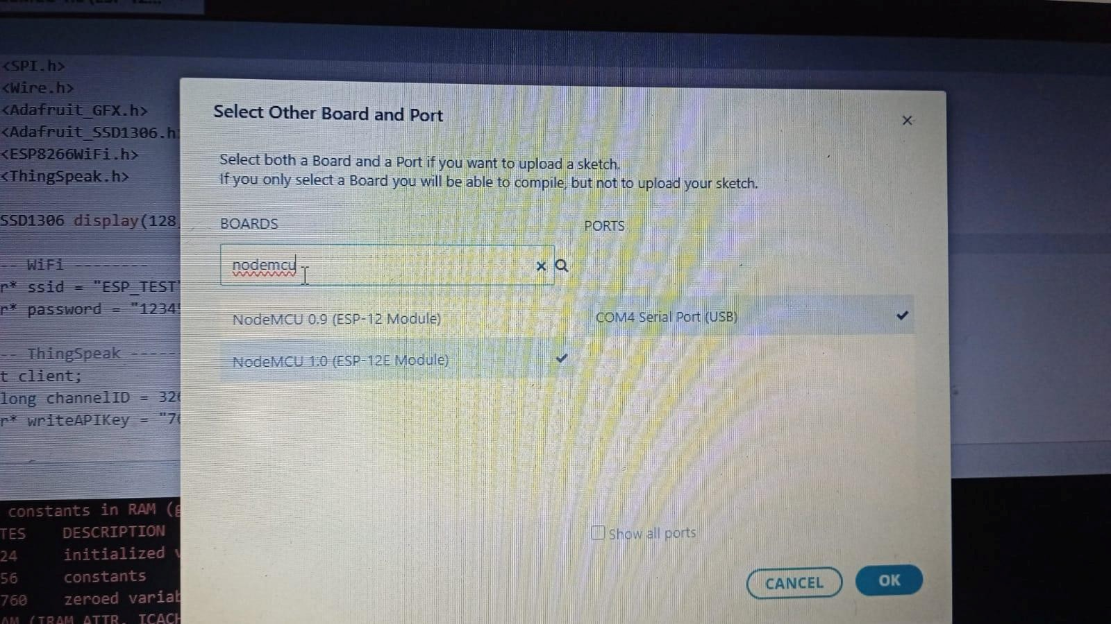
Step 8:Upload the code
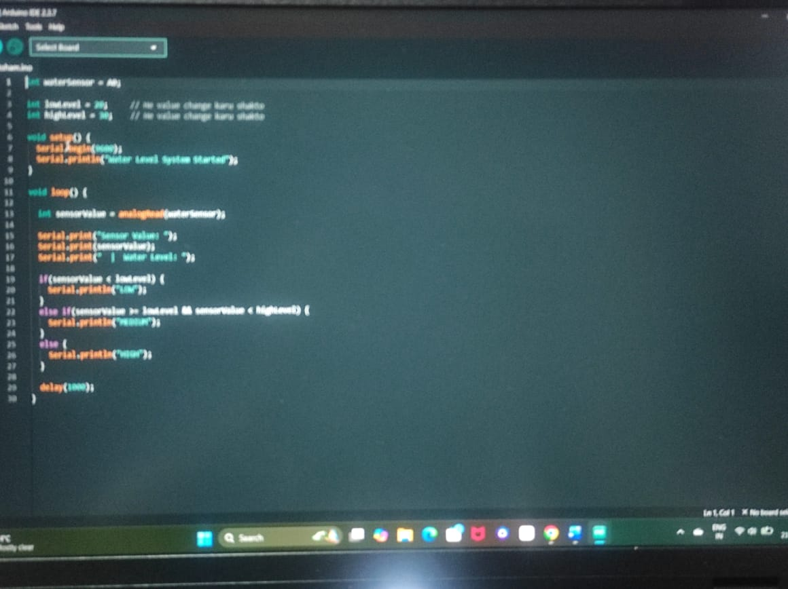



Future Scope :
The Automatic Water Level Controller using ESP8266 can be improved and expanded in many ways. The current system only monitors water level, but in the future it can be upgraded to a smart water management system.
IoT-Based Monitoring
Since ESP8266 has built-in WiFi, the system can be connected to the internet.
- Water level data can be monitored using a mobile phone.
- Data can be uploaded to cloud platforms.
- Users can check tank level from anywhere.
Mobile Application
A mobile app can be developed to:
- Show live water level.
- Send notifications when tank is full or empty.
- Provide alerts in case of water shortage.
Automatic Motor Control
In future, a relay and motor can be added:
- Motor turns ON when water level is low.
- Motor turns OFF when tank is full.
This will make the system fully automatic.
LCD or OLED Display
A display can be added to:
- Show water level percentage.
- Display system status.
- Indicate errors.
SMS or Email Alerts
The system can send:
- SMS alerts
- Email notifications
when the tank becomes empty or full.
Use of Advanced Sensors
More accurate sensors like:
- Ultrasonic sensor
- Float sensor
can be used for better measurement.
Smart Home Integration
The system can be connected with:
- Home automation systems
- Smart assistants
for complete smart control.

Conclusion
The Automatic Water Level Controller using ESP8266 is a simple, low-cost, and efficient system for monitoring water level in tanks.
The system successfully:
- Detects water level.
- Monitors tank status continuously.
- Reduces water wastage.
- Reduces manual checking effort.
- Saves time and electricity.
Using ESP8266 makes the system modern and upgradeable because it supports WiFi communication. The project demonstrates how embedded systems can solve real-life problems effectively.
Overall, this project provides a practical solution for water management and can be expanded into a complete smart water control system in the future.



References :
- YouTube Reference –
Project reference and implementation guidance taken from a YouTube tutorial.
URL: https://youtu.be/u-gq7wABn9Q?si=jdlq0EduSs7s5yBf
- Arduino IDE –
Software used for writing, compiling, and uploading the program to the ESP8266 board. URL: https://www.arduino.cc/en/software
- Pulse Sensor and Circuit Connections –
Information related to the pulse sensor and hardware connections was referred from online resources and Google search.
- Mentor Guidance –
Guidance and support were provided by Sahil Sir during the design, development, and testing phases of the project.
- Components Purchased –
ESP8266 (NodeMCU), pulse sensor, OLED display, LEDs, and connecting wires were purchased from local electronics stores.



Glossary :
ESP8266 (NodeMCU):
A low-cost WiFi-enabled microcontroller used as the main controller in this project. It reads sensor data, processes heart rate values, and uploads data to the cloud.
Water klevel sensor:
To detect water level is high or low
Arduino IDE:
An Integrated Development Environment used to write, compile, and upload programs to the ESP8266 microcontroller.
Analog Pin (A0):
A pin on the ESP8266 used to read analog signals from the pulse sensor.
IoT (Internet of Things):
A technology that enables devices to connect to the internet and exchange data without human intervention.

